**GENESIS (Lucene Service)**

**PLACES:**

1. **Paderborn**

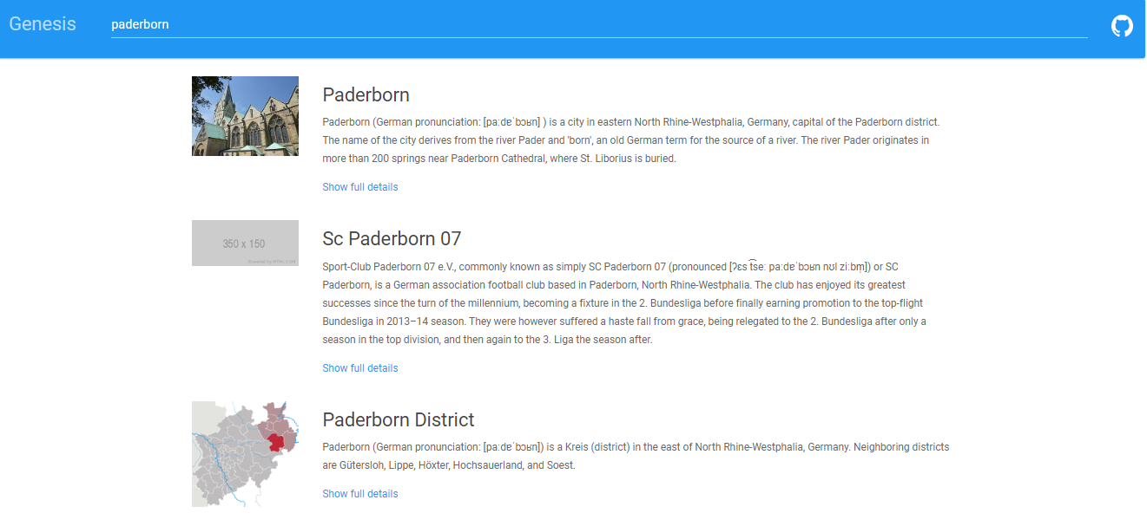

1. **Dresden**

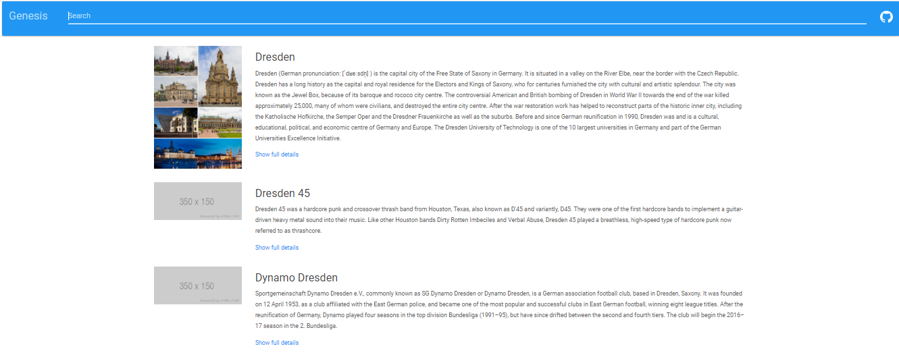

**PERSONS:**

**1) Donald Trump**

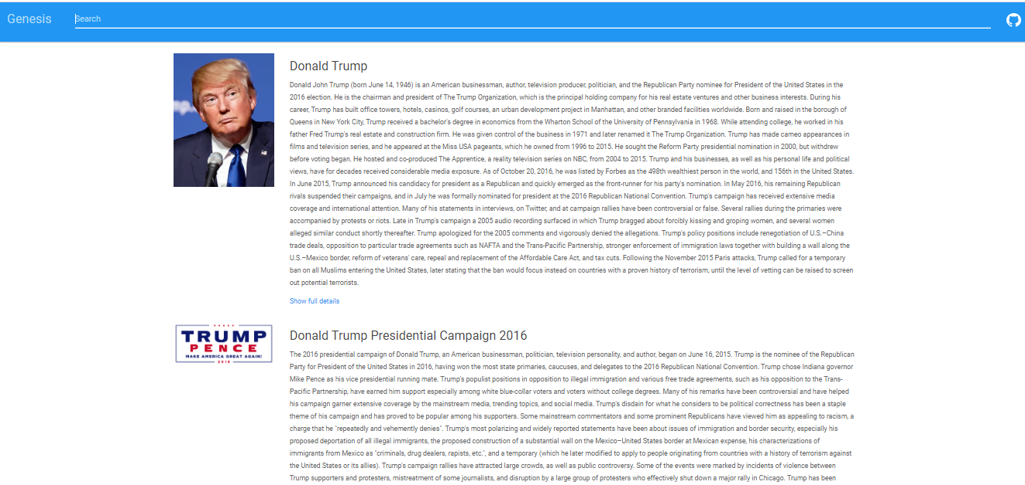

1. **Hitler**

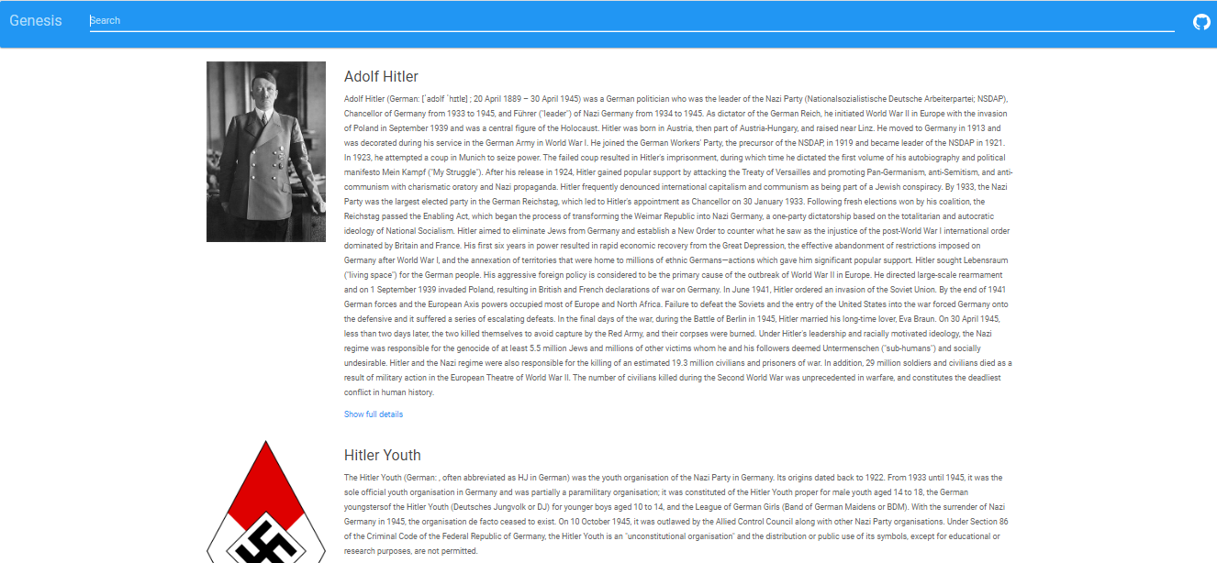

**ORGANIZATIONS:**

1. **Microsoft**

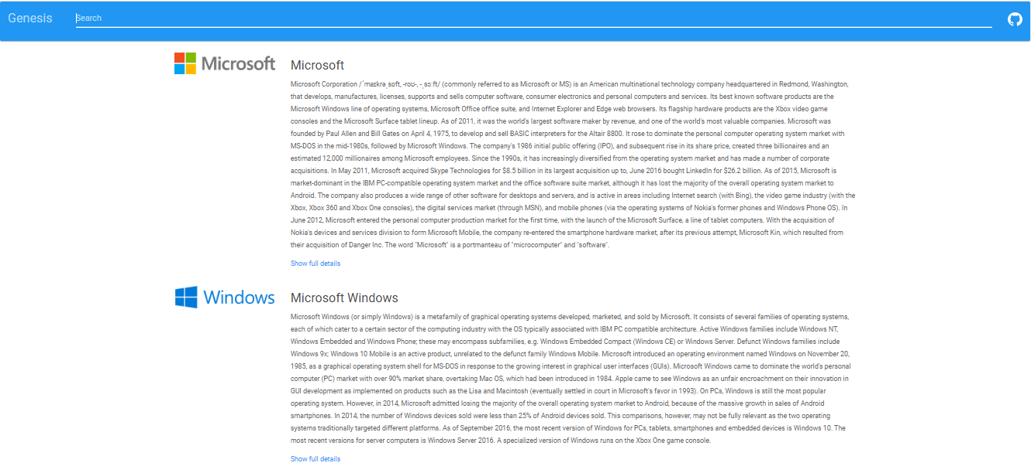

1. **IBM**